San Jose State University

EE250 (Section 2) Fall 2019 Prof. Kamali

Solution to Problem Set #6

- Problem 5.98
Clearly for 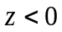, 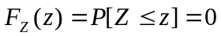. For 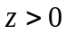, we use the following figure to compute the double integral.

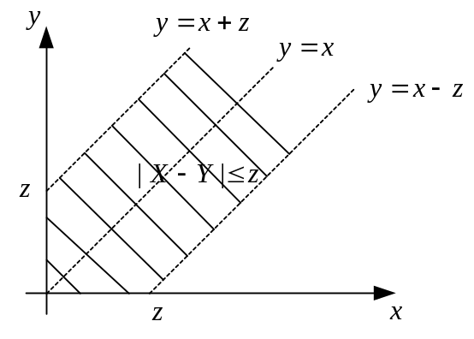

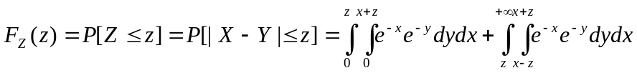

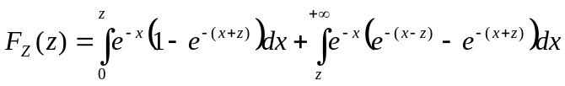

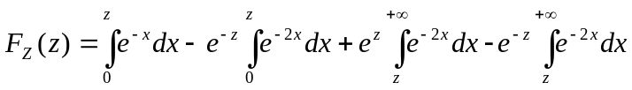

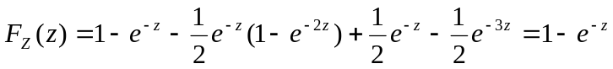

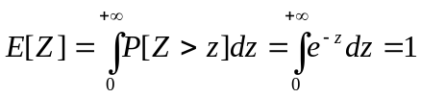

- Problem 5.106
Clearly for 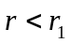 and 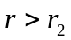, 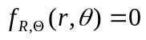.

For 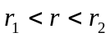, 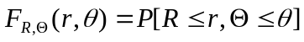

Since the distribution of 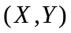is uniform, the above probability is simply the ratio of the highlighted area to the total area.

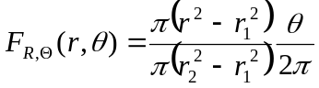

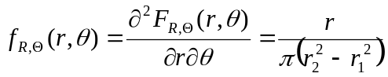 , 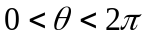

- [Midterm, Spring 2014] The joint pdf of the random pair 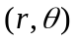is given as follows.

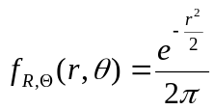 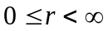,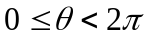

Find the probability that lies in the following region.

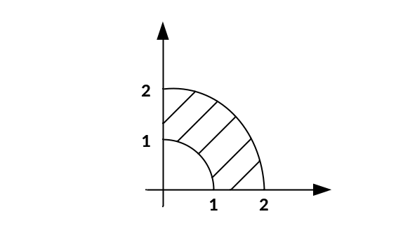

Solution:
To find the probability, we need to integrate the pdf over this region.

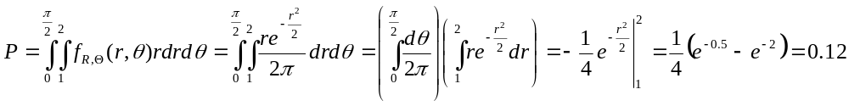

- [Midterm, Fall 2014] Suppose 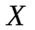 and 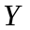are two independent uniform random variables between [0,1]. Find the pdf of 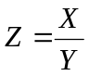.

Solution:

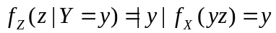 for 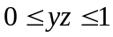 or 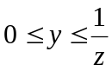

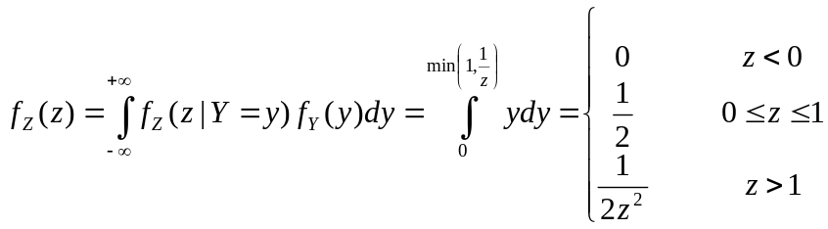

Alternatively, we can find the cdf and pdf as follows.

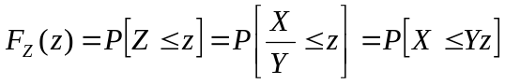

The region 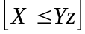 is shown in the following figures for both cases of 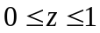and 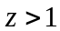.

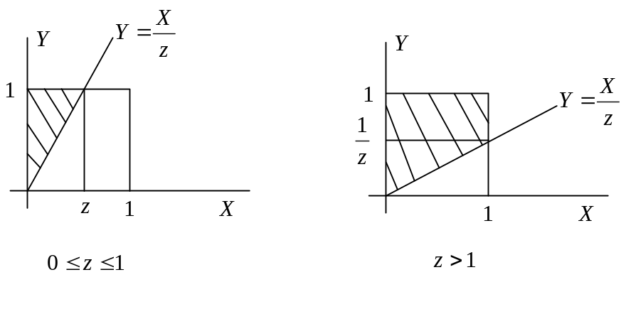
Since and are independent and uniform, the probability are simply the areas of the regions which will be 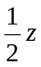and 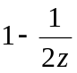, respectively whose derivatives will lead to the same pdf as above.

- [Midterm, Spring 2015] The joint pdf of the random pair is given as follows.

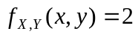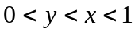

Find the pdf of 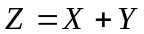.

Solution:

Since and are between 0 and 1, then 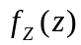is nonzero only for 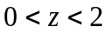.

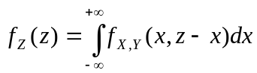

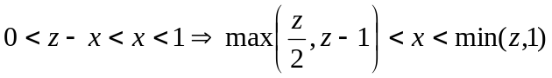
Since , then 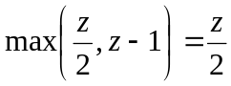 and thus
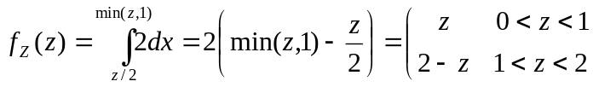

- [Final, Spring 2015] The joint pmf of the discrete random pair is given in the following table. Find 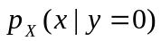.

 | 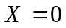 | 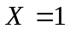 | 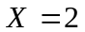
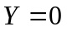 |  | 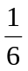
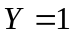 |  |  | 0
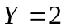 |  | 0 | 0

Solution:

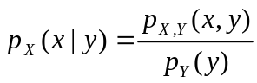

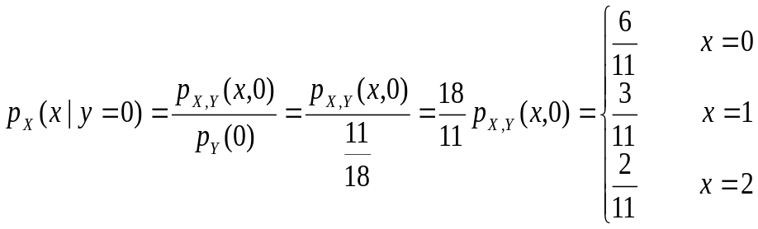

- [Final, Spring 2017] The joint pmf of the discrete random pair 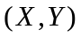 is given in the following table. Find 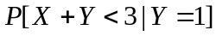.

 | 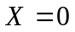 |  | 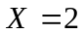 | 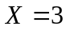
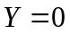 | 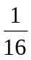 |  | 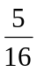 | 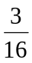
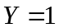 | 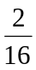 | 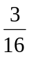

Solution:

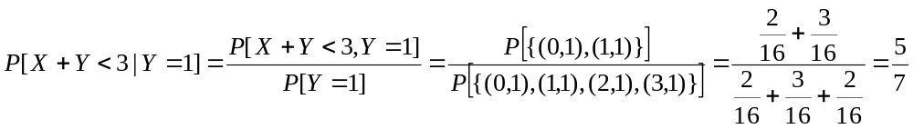

- [Midterm, Summer 2008] Supposeand are two independent uniform random variables between and and 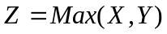.

- Find 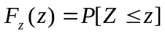.
- Find 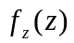(pdf of 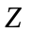).

Solution:
a)

Since and are both between and, 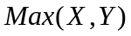is also in this range and thus 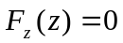for and 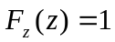 for 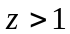. For 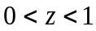, we have

b) 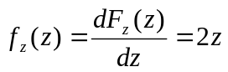 for

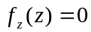 for and .

- [Midterm, Fall 2008] The joint pdf of the random pair is defined as follows.

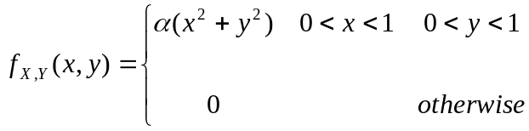

- Find .
- Find 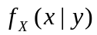.
- Find 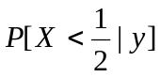.

Solution:
a) 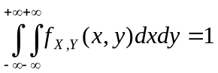
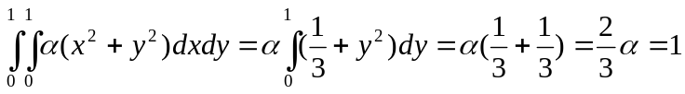

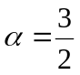

b) 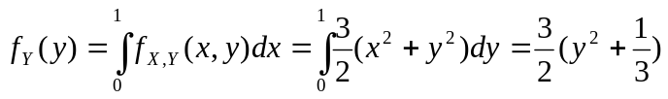

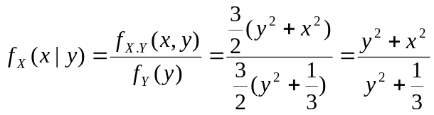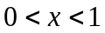

c) 